LAB 5

NAME : SHEEFA NAAZ
ROLL NO. : 2128085
DATE: 24-08-2023
SECTION : CSSE 2

QUES 1: Write an R-script to analyze whether the given year is a leap year or not?

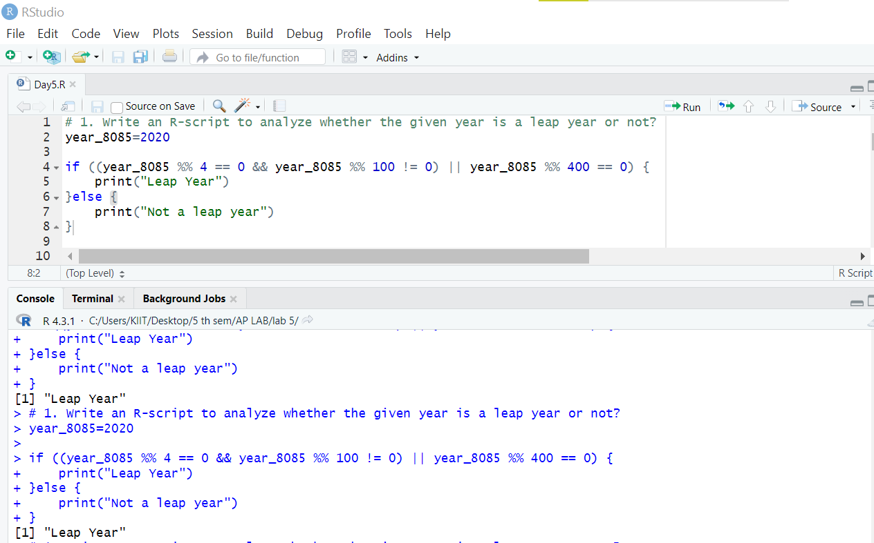

QUES 2:Write an R-script to enter a 3-digits number and check whether it is palindrome no. or not using if else only?

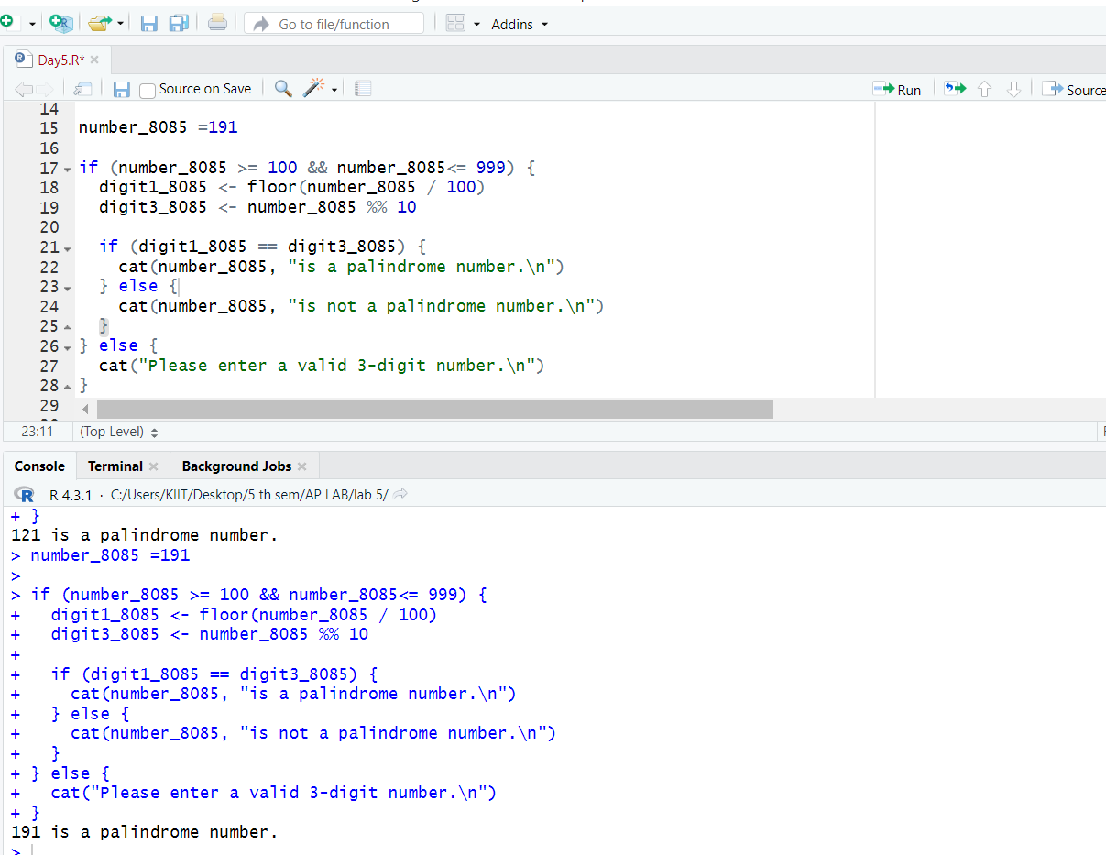

QUES 3. Write an R-script to enter marks in 3 subjects and then calculate the total mark and average. Assign the grade according to the B.Tech evaluation system.

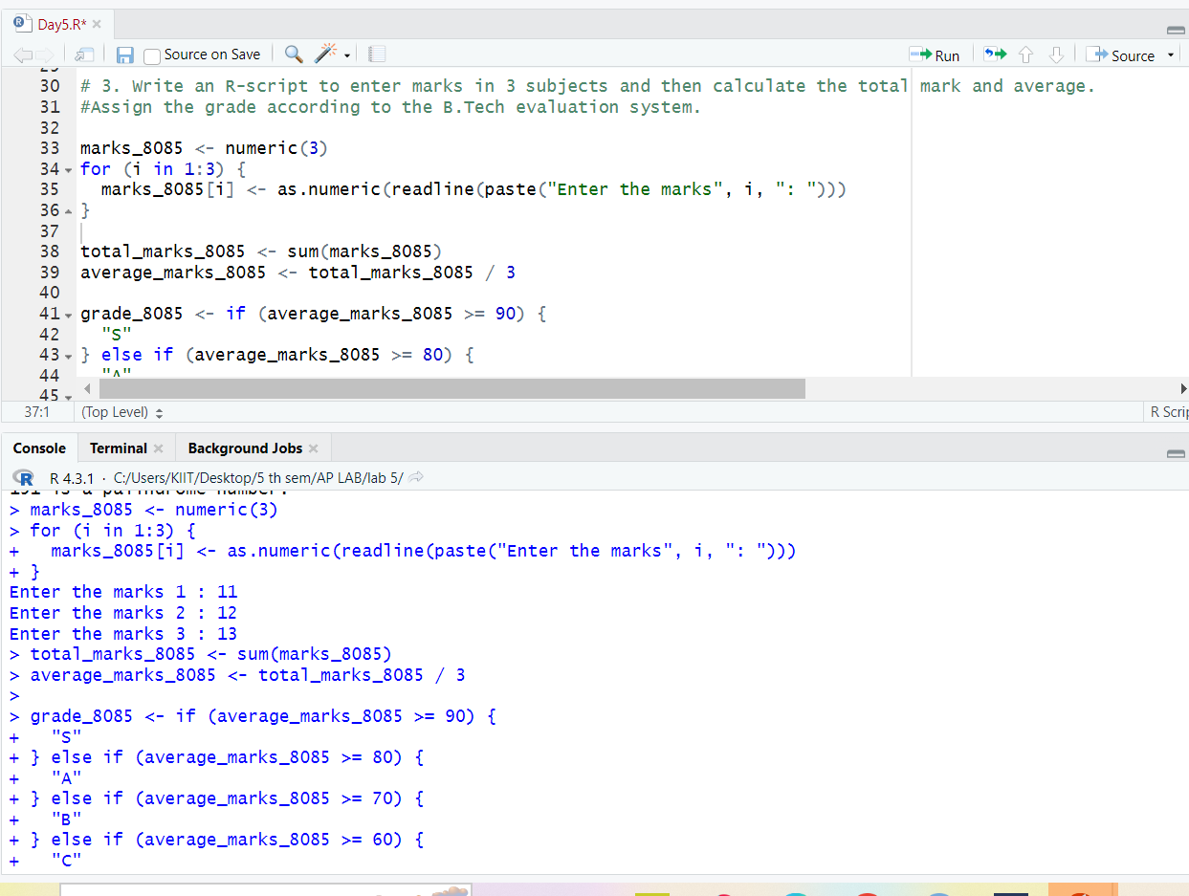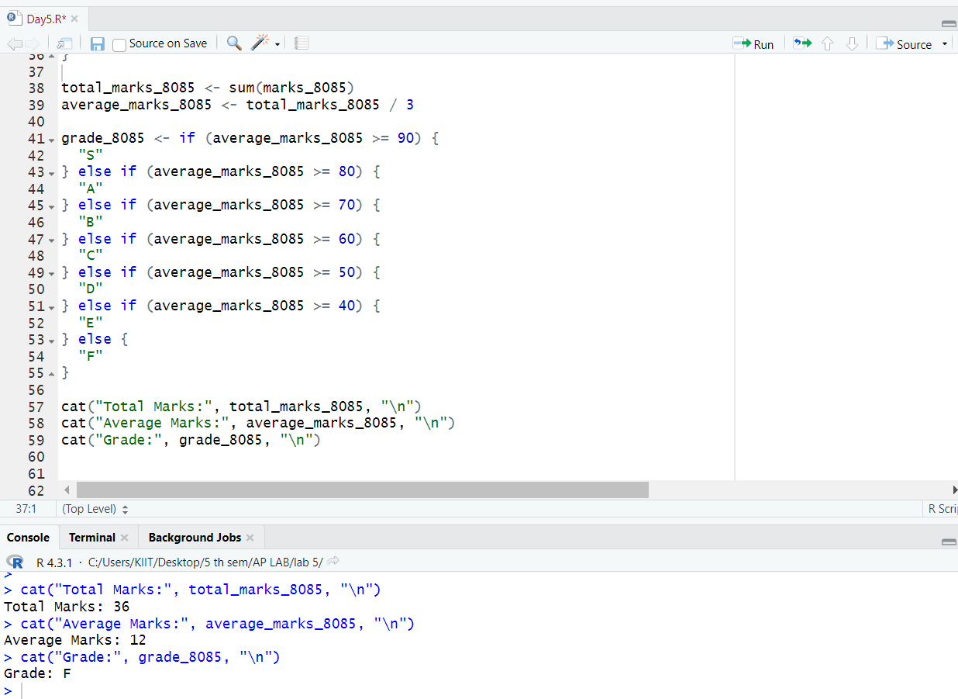

QUES 4. Write an R-script to design a menu driven program as follows and then evaluate any one of the operations according to your choice using switch case statement.

1. Area of circle
2. Area of rectangle
3. Area of Triangle

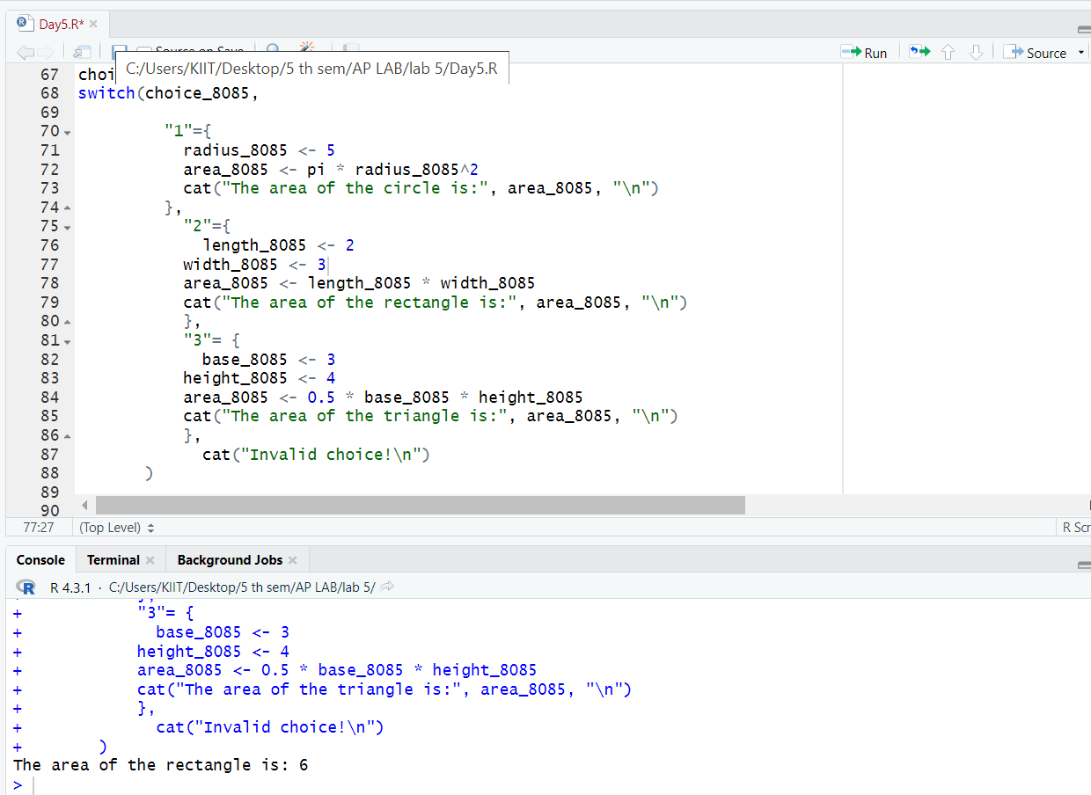

QUES 5. Write an R-script to design a menu driven program as follows and then display any one of the colors according to your choice using switch case statement.

R- Red
G- Green
B- Blue

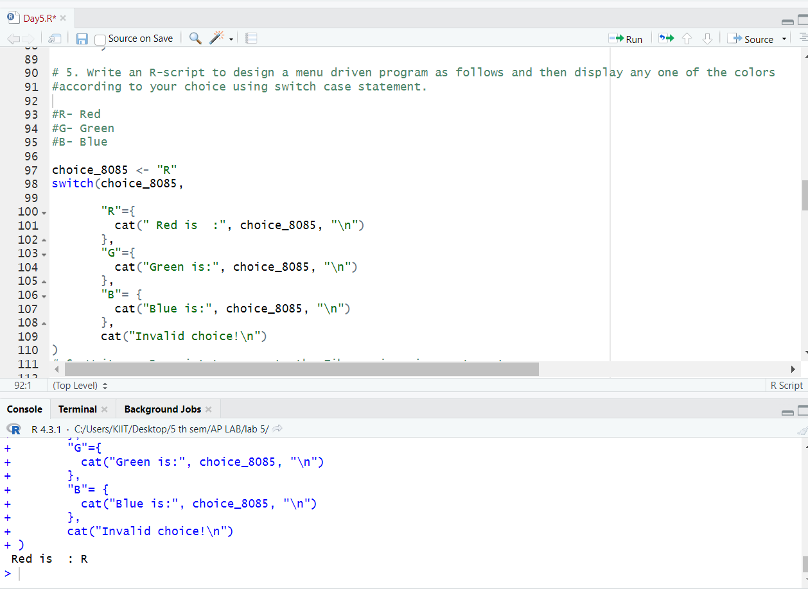

QUES 6. Write an R-script to generate the Fibonacci series up to n terms.

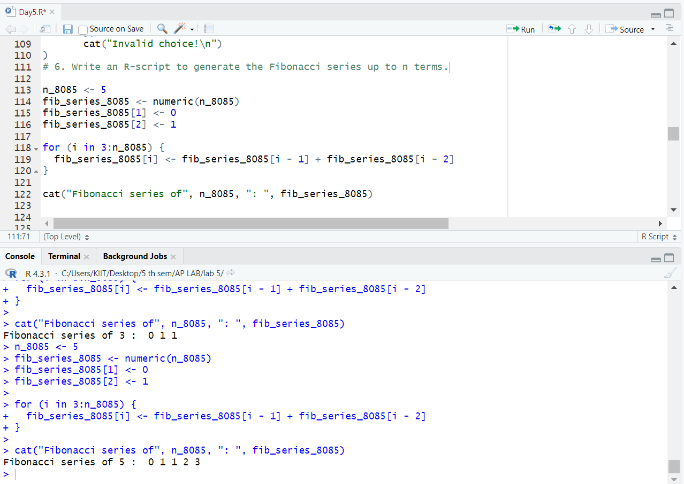

QUES 7. Write an R-script to check whether an input integer is perfect number or not.

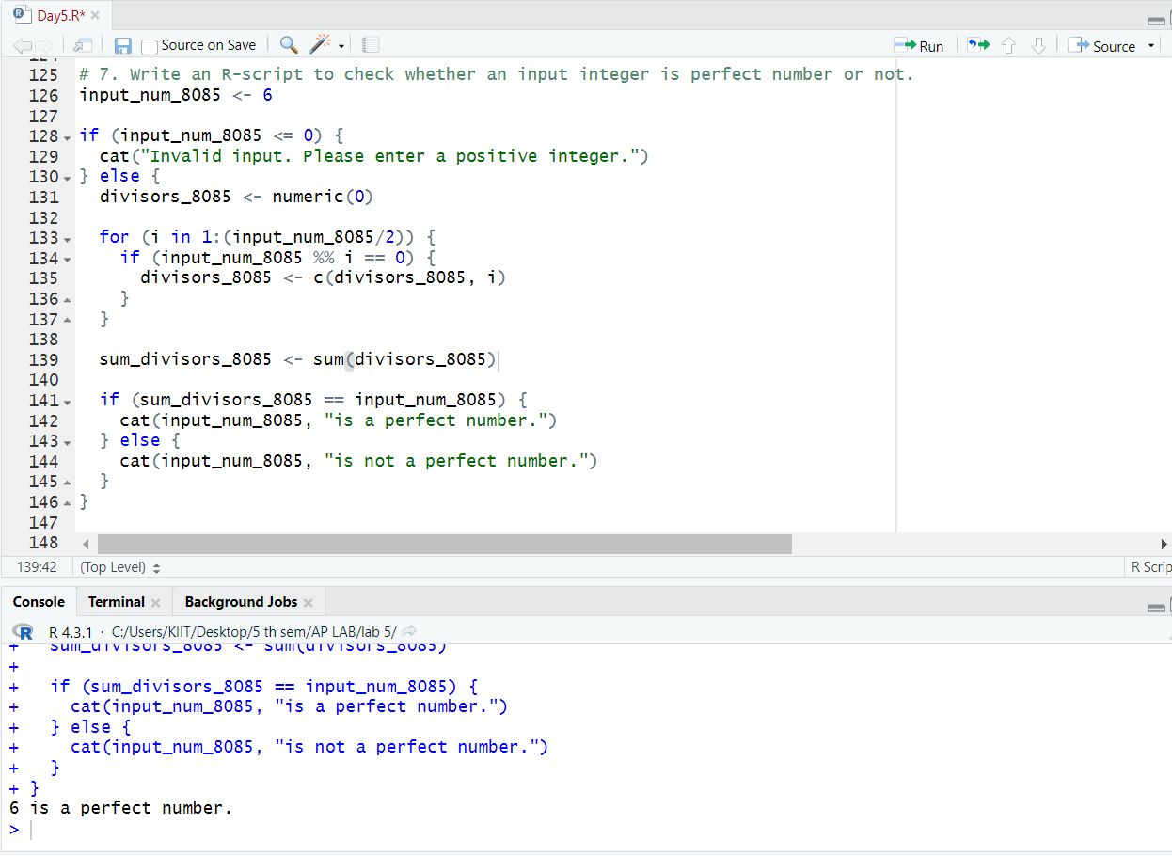

QUES 8. Write an R-script to sum the series S=1+(1+2)+(1+2+3)+...+(1+2+3+...+n).

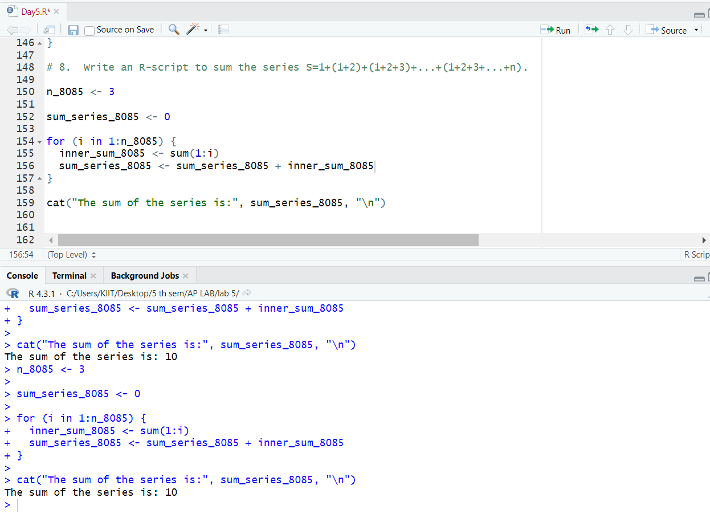

QUES 9. Write an R-script to check whether an integer number is an Armstrong number or not.
For example, 153 = ( 1 * 1 * 1 ) + ( 5 * 5 * 5 ) + ( 3 * 3 * 3 )

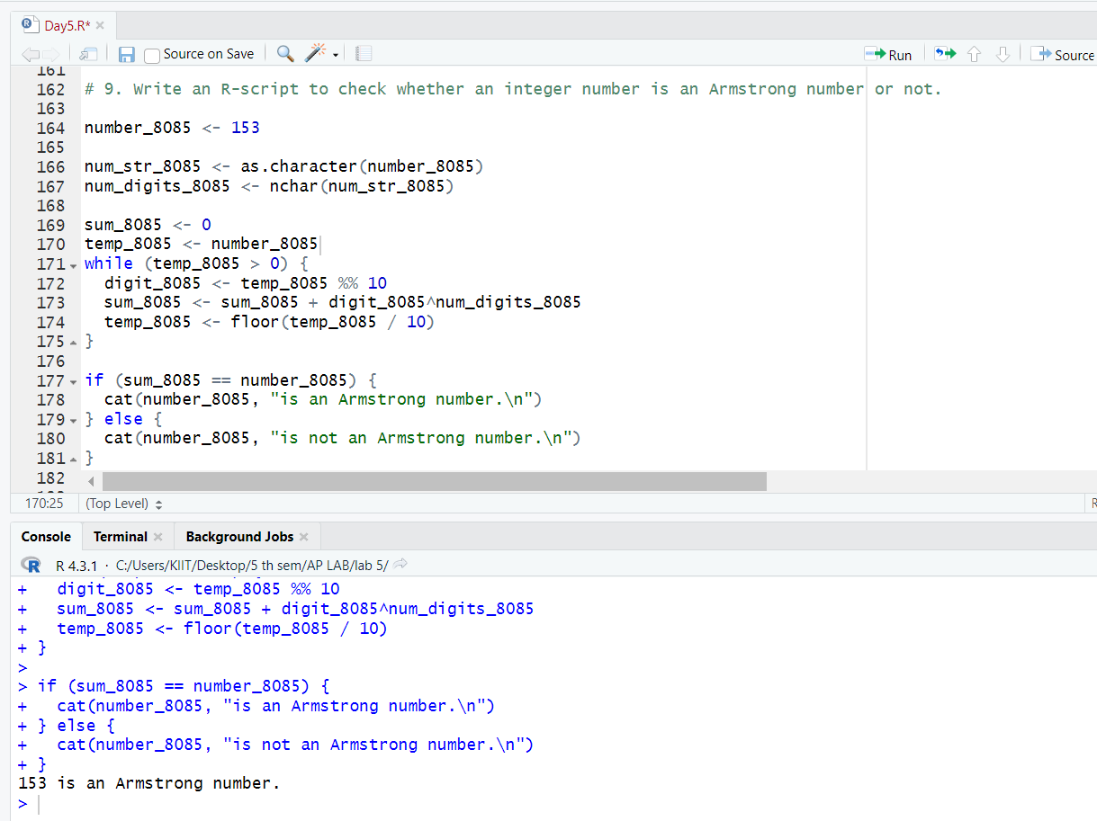
QUES 10. Write an R-script to print the following pattern for n rows. Ex. for n=5 rows.

1
2 1
1 2 3
4 3 2 1
1 2 3 4 5

